Regulations:
A18

H.T No

Sreenidhi Institute of Science and Technology
(An Autonomous Institution)
Code No: 7BC03 Date: 24-June-2019 (AN)

B.Tech I-Year I-Semester External Examination, June-2019 (Supplementary)
ENGINEERING MECHANICS (ME)

Time: 3 Hours Max.Marks:70

Note: a) No additional answer sheets will be provided.
b) All sub-parts of a question must be answered at one place only, otherwise it will not be valued.
c) Missing data can be assumed suitably.

Part - A Max.Marks:20

Answer all QUESTIONS.

1. | Determine the resultant of an 800N force acting towards eastern direction and a 500N force acting towards north eastern direction. | [2M]
2. | Define the principle of virtual work.
3. | Define principal axes and principal moment of inertia. | [2M]
4. | Differentiate between “Mass moment of inertia” and “Area moment of inertia” | [2M]
5. | A point P moves along a straight line according to the equation, x= 4t³ +2t+5, where x is in meters and t is in seconds. Calculate the velocity and acceleration at t=3 seconds. | [2M]
6. | Define Co-efficient of restitution. | [2M]
7. | How do you represent the inclined roller support in structures in free body diagram. | [2M]
8. | What is meant by pivot friction? | [2M]
9. | Define conservation of linear momentum. | [2M]
10. | A semicircular area having radius of 100 mm is located in the XY plane such that its diameter coincides with the Y-axis. Determine the X-coordinate of the centroid. | [2M]
Part – B Max.Marks:50
ANSWER ANY FIVE QUESTIONS. EACH QUESTION CARRIES 10 MARKS.

11. |  | A force P is applied at θ⁰ to the string AOB as shown in Fig.1. If the tension in each part of string is 50 N, Find the direction and magnitude of force P for equilibrium conditions.  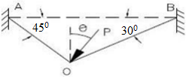  Fig.1 | [10M]
12. |  | Determine the force in each member of the truss in Fig.2 and indicate if the members are in tension or compression.  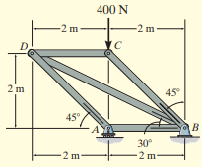  Fig.2 | [10M]
13. |  | Determine the centroid ( ) of the composite area shown in Fig.3  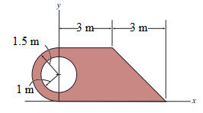  Fig.3 | [10M]
14. |  | Determine the moment of inertia of the composite area shown in Fig.4 about the centroidal y-axis.  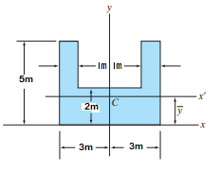  Fig.4 | [10M]
15. | a) | Discuss the rigid body fixed axis rotation. | [5M]
 | b) | A boy drops a stone from the top of well vertically downwards into it. The splash is heard by him after 6 seconds. Find the well depth by taking sound velocity as 400 m/s. | [5M]
16. |  | In Fig.5, If the coefficient of kinetic friction between the 100-kg crate and the plane µ_{k}=0.25, determine the speed of the crate at the instant the compression of the spring is x=1.5 m. Initially the spring is un-stretched and the crate is at rest.  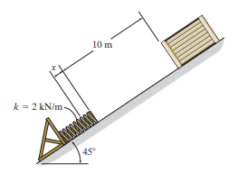  Fig.5 | [10M]
17. |  | Explain about:
 | a) | The equilibrium of co-planar force system. | [5M]
 | b) | Wedge friction. | [5M]
18. |  | Discuss about:
 | a) | Transfer formula for moment of inertia. | [5M]
 | b) | Elastic impact. | [5M]

-- 00 -- 00 –

